**A REPORT**

**ON**

**ANDROID APPLICATION DEVELOPMENT USING MEAN STACK**

**BY**

**SAHIL SHARMA 2014A7PS0408U COMPUTER SCIENCE**

**AT**

**BITS Pilani, Dubai Campus**



**BITS Pilani, Dubai Campus**

**Dubai International Academic City (DIAC)**

**Dubai, U.A.E**

**(JANUARY 2018 - MAY 2018)**

**A REPORT**

**ON**

**ANDROID APPLICATION DEVELOPMENT USING MEAN STACK**

**BY**

**SAHIL SHARMA 2014A7PS0408U COMPUTER SCIENCE**

**Prepared in Partial Fulfillment of the**

**Design Project Course**

**AT**

**BITS Pilani, Dubai Campus**



**BITS Pilani, Dubai Campus**

**Dubai International Academic City (DIAC)**

**Dubai, U.A.E**

**(JANUARY 2018 - MAY 2018)**

**BITS Pilani, Dubai Campus**

**Dubai International Academic City (DIAC)**

**Dubai, U.A.E**

Station: BITS Pilani, Dubai Campus Location : Dubai

Duration: 21-Jan-2018 to 30-May-2018 Date of Start: 21-Jan-2018

Date of Submission: 25-MAY-2018

Title of the Project: Android Application Development using MEAN stack

Student Name: Sahil Sharma Student ID: 2014A7PS0408U

Discipline of Student: Computer Science

Name and Designation of Experts: Mr Nand Kumar

Name of the Faculty: Mr Nand Kumar

Key Words: Android, Java, XML, MongoDb, Express, AngularJS, Node.js, C++, Firebase Database

Project Areas: Android Application Development, REST Apis, MEAN stack, Location Tracker, Database Management,

Abstract: The Scope of the project revolves around a new way of taking attendance, a common notice board for the students at Bits Pilani, Dubai Campus. Classroom updates and notifications will also be shown. It’s basic idea is to let the students concentrate on studying and the teachers concentrate on teaching while this app takes care of the rest. The attendance is taken and managed in a very organized way and the app displays all the notices uploaded by the teacher with an ease.

Signature of the Student Signature of PS Faculty

Date: 30-MAY-2018 Date: 30-MAY-2018

**ACKNOWLEDGEMENTS**

Firstly, I would like to express my heartfelt gratitude to Prof. R. N. Saha, Director BPDC who has given us an opportunity to apply and understand our engineering concepts in a practical atmosphere.

My sincere gratitude to Nand Kumar, my Project Faculty, for providing me with generous support and coaching during my Project. He also offered all the assistance required for successful completion of this report.

Signature of the Student

Date: 30-July-2017

**Contents**

**Abstract**

Acknowledgement

Table of contents

List of Figures

List of tables and List of Screenshots

**Chapter 1 INTRODUCTION**

1.1 Project Summary............................................................................. 1

1.2 Purpose........................................................................................ 1

1.3 Scope........................................................................................ 2

**Chapter 2 PROJECT MANAGEMENT**

2.1 Project Planning and Scheduling....................................................................... 3

2.1.1 Project Development Approach................................................................3

2.1.2 Project Plan……………………...................................................................4

**Chapter 3 SYSTEM REQUIREMENT STUDY**

3.1 User Characteristics........................................................................................ 6

3.2 Technology Review........................................................................................ 7

3.2.1 Project Tools........................................................................................ 7

3.2.2 Software Requirements............................................................................7

3.2.3 Hardware Tools…………..........................................................................8

**Chapter 4 ANALYSIS**

4.1 Study of Current System.....................................................................................9

4.2 Feasibility Study………........................................................................................9

4.2.1 Operational Feasibility................................................................................9

4.2.2 Technical Feasibility...................................................................................9

4.3 Function of the System.......................................................................................9

**Chapter 5 SYSTEM DESIGN**

5.1 System Procedural Design..................................................................................12

5.1.1 System Flow-Chart....................................................................................12

5.2 Input/Output and Interface Design........................................................................14

**Chapter 6 IMPLEMENTATION, PLANNING AND DETAILS**

6.1 Implementation Environment...............................................................................17

6.2 Modules Specification.......................................................................................... 17

6.3 Security Features................................................................................................. 18

**Chapter 7 TESTING**

7.1 Testing Plans........................................................................................ 20

7.2 Testing Strategy........................................................................................ 20

7.3 Test cases........................................................................................ 21

7.3.1 Test Case for Students.............................................................. 22

7.3.2 Test Case for Teachers.............................................................. 23

**Chapter 8 SCREENSHOTS AND CODE STRUCTURE**

8.1 Screenshot for Notification Activity....................................................................24

8.2 Screenshot for Show Uploads........................................ ……..25

8.3 Screenshot for Server Code.................................... …26

8.4 Screenshot for Data Saved in Database...........................................................27

8.5 Screenshot for Notices saved in the database……….......................................27

8.6 Screenshot for Data with key............................................................................28

**Chapter 8 LIMITATIONS AND FUTURE SCOPE**

8.1 Limitations........................................................................................ 29

8.2 Future Scope........................................ 29

**Chapter 9 CONCLUSION AND DISCUSSIONS**

9.1 Conclusion........................................................................................ 30

9.2 Summary of the Project........................................ 30

**Chapter 9 REFERENCES**……………………………………………………………...31

List of Figures

|  |  |  |
| --- | --- | --- |
| FIG NO. | NAME OF THE FIG | PAGE NO |
| Fig 2.1 | Increment Model | 3 |
| Fig 4.1 | Use Case Diagram for User | 10 |
| Fig 4.2 | Use Case Diagram for Teacher | 10 |
| Fig 4.3 | Use Case Diagram for Student | 11 |
| Fig 5.1 | System Flow Chart for Students | 12 |
| Fig 5.2 | System Flow Chart for Teacher | 13 |
| Fig 5.3 | Sign in Form | 14 |
| Fig 5.4 | Register Form | 14 |
| Fig 5.5 | Profile | 15 |
| Fig 5.6 | GPS Location | 15 |
| Fig 5.7 | Notices Upload | 16 |
| Fig 5.8 | Notify Activity | 16 |

**List of Tables**

|  |  |  |
| --- | --- | --- |
| TABLE NO. | NAME OF THE TABLE | PAGE NO |
| TAB 3.1 | List of Project Tools | 7 |
| TAB 3.2 | List of Software Required | 7 |
| TAB 3.3 | List of Hardware Required | 8 |
| TAB 7.1 | Test Case for Student | 22 |
| TAB 7.2 | Test Case for Teacher | 23 |

**List of Screenshots**

|  |  |  |
| --- | --- | --- |
| SCREENSHOT NO. | NAME OF THE TABLE | PAGE NO |
| Screenshot 1 | Notification Interface | 24 |
| Screenshot 2 | Show details Upload | 25 |
| Screenshot 3 | Server Side | 26 |
| Screenshot 4 | Data stored in database | 27 |
| Screenshot 5 | Notices Uploads | 27 |
| Screenshot 6 | Uploads with key | 28 |

**Chapter 1: INTRODUCTION**

* 1. **PROJECT SUMMARY**

This Application is built for BPDC staff and students for a new way of taking attendance and providing a common notice board for all the students for their convenience.

This is an application, which locates the current location to take attendance of the students for the teacher to review it. The student can select the exact location and mark their attendance in a very easy way. Once the student becomes a registered user of the app, he/she can create own account and manage it the way he/she likes to use.

This software consists of a few smooth navigational and silent functions to manually guide the users. The search facility allows the students to find precisely what they desire without losing much of their time. The Get Location serves as a reference for the students as they continue to mark their attendance. The other facilities include superior search, progress steps, Notice boards, sorted search results, etc.

This application is made user-friendly and convenient to such an extent that the user is never required to type the identical data more than as once (except passwords).

The application consists two main tabs. From these areas, the user can fully manage every part of the entire app. The teacher can view and process the attendance marked by the students. He can print the attendance list for a hard copy and invoices. The inventory control and full dealer management also controlled by him. In short, he has the overall control on all of the functions of the application. And the teacher can upload the notices for the students to see and notify all the students about that.

* 1. **PURPOSE**

The main goal of this project is to develop a generic application that can be deployed on devices running on AndroidOS and make it easy for the Staff and the students to save time and concentrate on studying.

The comfort of being able to get the genuine and the accurate location is beyond imagination. So, convenience for the Students and the Teachers is one of the basic objective of this application.

A user-friendly environment helps the user mark their attendance with great ease and efficiency. Moreover, it also helps the teacher to review and upload the attendance on the go. So, designing a user-friendly interface can also be considered as one of the many achievements of this project. Then the teachers can upload the notices and they’re saved and displayed in a different tab.

A try has also been made to get the accurate location and genuine results. In short, the key goals are – Taking Attendance, promoting to view the attendance and making the college notices convenient and accessible for everyone.

* 1. **SCOPE**

Project scope directs to the contents of the project in terms of what will be there in the project and what will not. The scope of this project includes the following features:

* Getting the location as accurate as possible
* Enables easy adding, deleting and modifying of attendance
* Easy back navigation
* Not confirmed attendance removed automatically
* Save attendance information once entered
* Recommendations on locations by location detecting
* Password management
* Account confirmation either through email or via the web
* Common notice board for everyone
* Easy notifications

The list of things (or anything else) outside the scope of the project would consist is what’s called scope creep. The project scope will also include:

* Authorization of the Students and staff
* Attendance Performance
* Data from the college
* Multimedia like video or Flash Automatic
* Chat box between teachers and students

**Chapter 2: PROJECT MANAGEMENT**

**2.1 PROJECT PLANNING AND SCHEDULING**

**2.1.1 Project Development Approach**

To deal with the real problems in an industry, an IT engineer or group of engineers must work with a development strategy that cover the process, approach, and tools. This plan is mostly denoted to as a process model or a software engineering paradigm. A process model for engineering is chosen based on the kind, features and application, the methods and tools to be used, and the controls that are required.

This model, as showed in the FIGURE 3.1 below got its name from the way in which the software works and how the software is named. More precisely, first the model is designed, then it’s implemented and tested as a series of incremental until the final product is obtained. A build consists of bits of code from various modules that relate together to provide a specific function which will help the product work.

At each phase of the Model, another form is coded and after that it is coordinated into the structure, which is tried as entirety. The item is just considered as completed when it fulfills the greater part of its prerequisites.

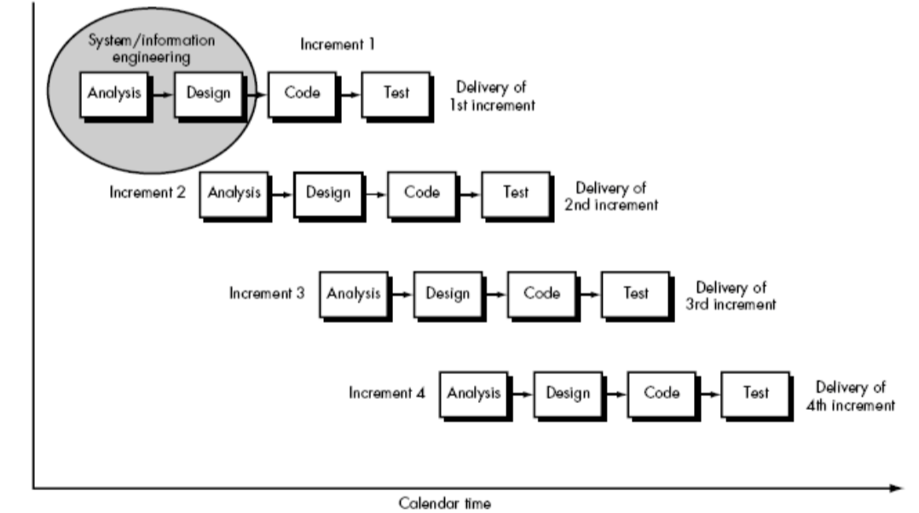

**FIG 2.1 INCREMENT MODEL**

**2.1.2 Project Plan**

The project plan provides with an estimate of how much cost, hard work, assets and time will it take to build up the entire thing. The venture is arranged into some number of modules. Building these modules needs great measure of specialized comprehension and inside and out learning of JAVA. It is difficult to figure the nitty gritty depiction of all the sub exercises. Likewise, the venture requires great level of R and D endeavors and achieving the task relied upon the correct way towards conclusive outcomes. This task of Android application requires taking participation and give a typical stage to everybody.

**Project Milestones**

Tasks should be associated with project milestone. A milestone is accomplished when one or more work products has been approved with good quality after reviewing. Project MiIestones incIude compIetion of some given tasks in given time Iimits like Product statement defined, OCl

(Output/Control/lnput) defined, OCl definition complete, software elements defined,

Reusable components identified, Technical feasibility assessed, Scope document complete.

**Project Deliverables**

Every scheduled task should’ve a defined outcome. For software projects, the outcome is normally a work product (e.g., the design of a module) or at least part of working product. Work products are often combined in deliverables.

**Project Roles**

A typical client may utilize a framework assuming number of various parts. While, a performing artist assume only one part of speaking to a class of outside elements (frequently). After cautious survey of prerequisites, four distinct modes are required by the product for collaboration: programming mode, test mode, checking mode, and investigating mode. In this way, four on-screen characters can be characterized: software engineer, analyzer, screen, and troubleshooter. At times, every one of the parts can be played by the machine administrator. In others, diverse individuals may assume the part of every on-screen character.

**Project Responsibilities**

Every specific team member should be assigned to the scheduled tasks.

**Project Dependencies**

A convenient technique for assessing the whole complexity of a proposed architecture is to keep in mind the dependencies between components within the architecture. These dependencies come from information/control flow within the system. Three types of dependencies:

* Sharing dependencies represent dependence relationships between the consumers who use the exact same resource or producers who produce for the exact same consumers.
* Flow dependencies represent dependence relationships between consumers and producers of resources.
* Constrained dependencies represent constraints on the relative flow of control among a set of activities.

**Chapter 3: SYSTEM REQUIREMENTS STUDY**

After discussing with the instructor, head and primary investigation, the required study for the project was done. A pre ROI was prepared which gave an idea of the exact amount of efforts required in people-person months, the incurred cost, the risks and the mitigating factors.

Different parameters were taken into consideration while considering the cost factor incurred in the project:

**Consultancy cost**: This cost is based on the running the project and its location.

**Hardware cost**: This cost is based on the cost incurred on the hardware utilized per person month like computer, tapes etc.

**Software cost**: This cost includes the cost incurred on the licensing of tools and software used in the project e.g. Oracle, Microsoft Office etc.

**3.1 USER CHARACTERISTICS**

There are basically two types of users in Application. The first type of user is Students and the second one is the Teachers. Both users have their own characteristics. The characteristics of the Users of the system will be described below so that we are able to judge what actually the application does.

The Student is a user who will be able to mark the attendance of their current location using a button. He can access through the login page once the user is verified user of the application. Student is also able to see the notices been put up. He can attend all the classes and mark the attendance under his email id and send it to the teacher to review it.

The teacherlogs in to their own profile, he will notice the attendance marked by all the students and can upload the new notices. The teacher can click on the check boxes to select multiple records, clicking on the button to ERP will take the record to the ERP and it will be uploaded. He will not see all the triggers raised. To ERP button can be accessed by only a Teacher.

The Notice tab is available for both of the user to see the notices.

* 1. **TECHNOLOGY REVIEW**
     1. **Project Tools:**

|  |  |
| --- | --- |
| Front-end Tools | Android Studio |
| Back-end Tools | MEAN stack |
| Platform | Android |

**Table 3.1 LIST OF PROJECT TOOLS**

In Table 3.1, the Project tools are given. The tools which are used in the project. Here’s a short summary about the products:

* Android Studio: It is the official integrated development environment for the Android platform which was developed by Google in 2013. It’s a JetBrains IntelliJ Idea software designed specifically for android development. It’s available for Windows, macOS and Linux
* MEAN stack: MEAN is a free and open-source JavaScript software stack for building dynamic web sites and web applications. The MEAN stack is MongoDB, Express.js, AngularJS, and Node.js
* Android platform: The platform used in this project is Android. Android is a software package and linux based operating system for mobile devices such as tablet computers and smartphones. It’s developed by Google and later the OHA (Open Handset Alliance). Java language is mainly used to write the android code even though other languages can be used.

**3.2.2 Software Requirements:**

|  |  |
| --- | --- |
| Application Front-end Tools | Android Studio 2.3 |
| Application Back-end Tools | Firebase Real-time Database, MEAN |
| Office Automation Tools | Microsoft Office |

**TABLE 3.2 LIST OF SOFTWARE REQUIRED**

In Table 3.2, the software required for the projects are given.

**3.2.3 Hardware Requirements (Recommended):**

|  |  |
| --- | --- |
| Application Installation | Android enabled GSM/CDMA phone |
| Internet Connection | Required |
| Version | 4.1 |
| Memory | 128mb |

**TABLE 3.3 LIST OF HARDWARE REQUIRED**

In Table 3.3, the hardware required for the installation of the application is given. Without this, the application won’t work.

**Chapter 4: ANALYSIS**

**4.1 STUDY OF CURRENT SYSTEM**

This project contains features such as register, login, detect location for taking attendance, upload notices and display them and also notify.

**4.2 FEASIBILITY STUDY**

**4.2.1 Operational Feasibility:**

This is the study of the current operational frameworks and alternative techniques for automating these assignments. It's motivation is to explore the present system, assess the plausible use of PC based strategies, select a conditional framework, cost assessment and proposed framework's adequacy, and assess the effect of the proposed framework on existing individual.

From the user point of view, this app here is easy to operate because it performs tasks step by step. The application is simple for smart phone user. So, it doesn’t need instructions on how to use it. No need to learn any special or specific command and training to use this application.

**4.2.2 Technical Feasibility:**

Technical Feasibility means the capacity of the undertaking to take favorable circumstances of the live condition of the innovation in following further change. The front-end instrument proposed is effortlessly workable with the present equipment design. The backend device here has the ability to hold and get the information required for utilizing the new framework.

This app uses the technology which is present in the world only. For registration and forget password, it uses internet to send the link. Technologies are improving day by day. So, it’s convenient to use the existing technology. So, there is no need for development of any new hardware to provide these facilities. This app runs on android operating system which is available in most of smart phone devices now a days. So, there is no need to get and install any new software or driver to run this application.

**4.3 FUNCTION OF THE SYSTEM**

* **What is Use Case?**

The Use Case diagram gives the user’s expectation from the application. The people who interact with the target system are known as actors. Feature’s systems that actors use are called use cases. Some use cases directly interact with other use cases while some indirectly, a relationship modeled using dependency arrows.

The basic goal of the Use Case diagrams is to identify all of the given features that the users expect from the system to support, but it does not give away any details about the implementation and the use of these features.

**4.3.1 USE CASE DIAGRAMS**

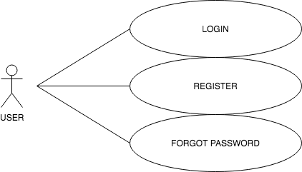

**FIG 4.1 USE CASE DIAGRAM FOR USER**

In FIG 4.1, the use case for the login activity is explained. On the default Screen, there will be three options: Login, Register and Forgot password. This will be common for both sales executive and the pricing analyst.

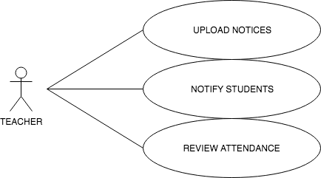

**FIG 4.2 USE CASE DIAGRAM FOR TEACHER**

In FIG 4.2, the use case for the login activity is explained. On the default Screen, there will be three options: Login, Register and Forgot password. This will be common for both sales executive and the pricing analyst.

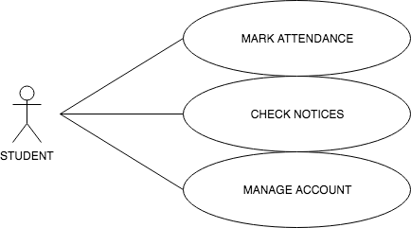

**FIG 4.3 USE CASE DIAGRAM FOR STUDENT**

In FIG 4.3, the use case for the login activity is explained. On the default Screen, there will be three options: Login, Register and Forgot password. This will be common for both sales executive and the pricing analyst.

**Chapter 5: SYSTEM DESIGN**

**5.1 SYSTEM PROCEDURAL DESIGN**

**5.1.1 System Flow Chart**

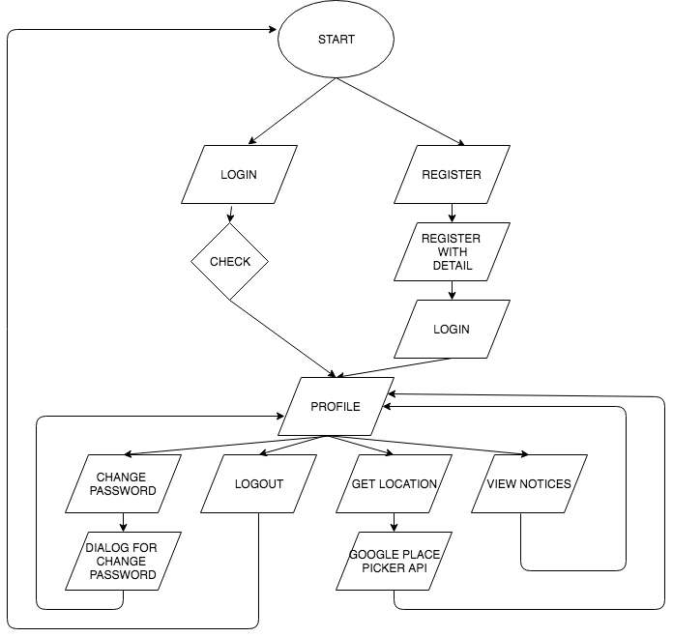

**FIG 5.1 SYSTEM FLOW CHART FOR STUDENT**

In FIG 5.1, the figure given is the flow chart for the application developed for the Student

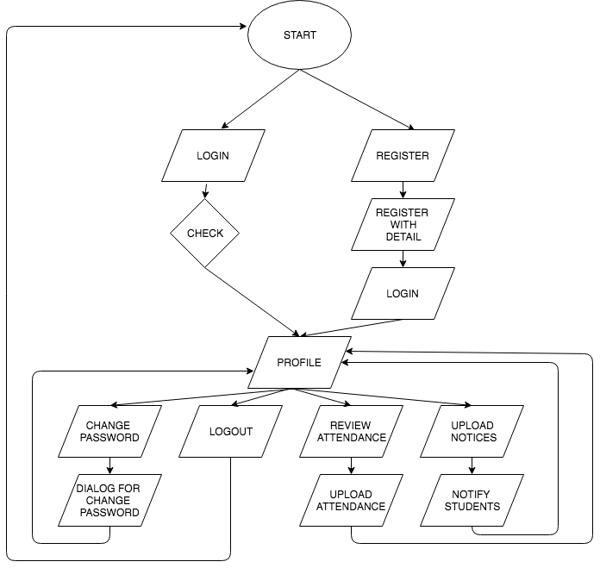

**FIG 5.2 SYSTEM FLOW CHART FOR TEACHER**

In FIG 5.2, the figure given is the flow chart for the application developed for the Teacher

**5.2 INPUT/OUTPUT AND INTERFACE DESIGN**

**5.2.1 Samples of Forms**

A) Sign in Form

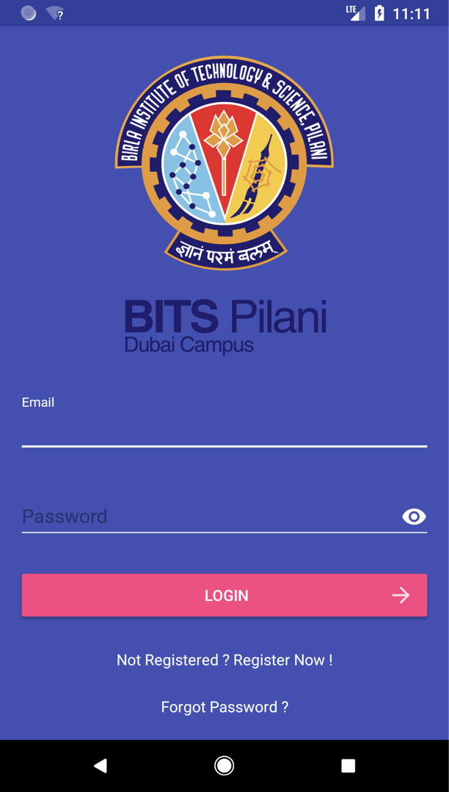

**FIG 5.3 SIGN IN FORM**

In FIG 5.3, the sign in screen is shown.

B) Register Form

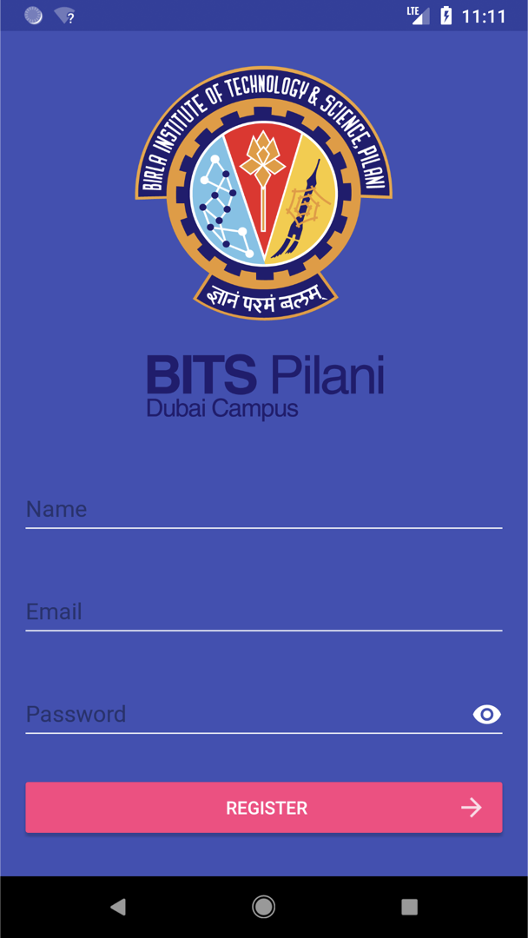

**FIG 5.4 REGISTER FORM**

In FIG 5.4, the register screen is shown.

C) Profile Activity

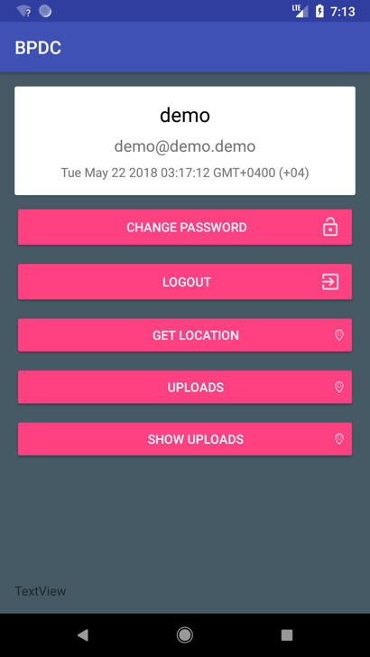

**FIG 5.5 PROFILE**

In FIG 5.5, the profile screen is shown.

D) GPS Activity

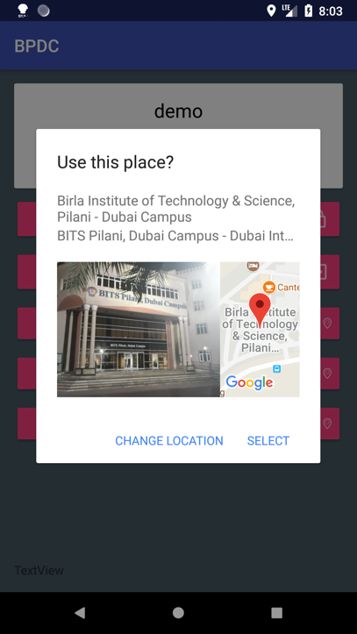

**FIG 5.6 GPS LOCATION**

In FIG 5.6, the detecting GPS location and choosing is shown.

E) Upload Activity

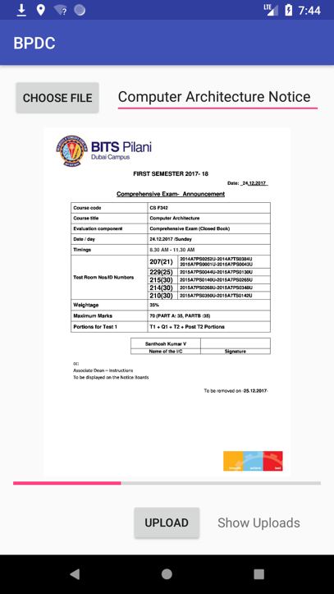

**FIG 5.7 NOTICE UPLOAD**

In FIG 5.7, the profile screen is shown.

F) Notify Activity

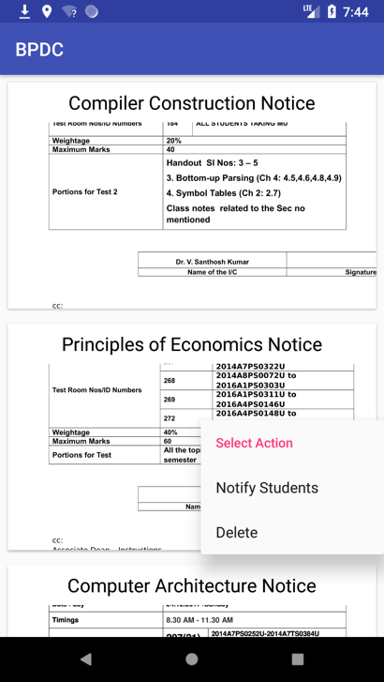

**FIG 5.8 NOTIFY ACTIVITY**

In FIG 5.8, the notify activity is shown.

**Chapter 6: IMPLEMENTATION PLANNING AND DETAILS**

**6.1 IMPLEMENTATION ENVIRONMENT**

As this application is an application which runs online, it can be accessed by any n number of users at any time. Different students from different places can mark their attendance simultaneously. Teachers can view the attendance, upload the notices at the same time. There is no limit for the number of students accessing this app. But updating on the location for the attendance is allowed only one time and only the teachers can do it. It has a wonderful UI design and it is user-friendly and adaptable that any new user can easily use and learn it without any difficulty.

**6.2 MODULES SPECIFICATION**

The entire app is divided into these four modules.

* Students Tools
* Teacher Tools
* Easy Navigation & Silent feature
* Product Management

The Modules which are currently covered are:

* **Student tools**

This module deals with all the student side controls. The student can log in to their account by giving the User-Name and Password. The students can mark their attendance, upload their personal information, change passwords, view all the notices placed, view attendance status, view their personalized messages, etc. In short, the student gets the complete liberty of managing his own account without any complexity.

* **Teacher Tools**

This module deals with all the teacher tools. The teacher can sign in their account and review all the attendance by the students and pass it to the students if they are considerable and acceptable. Teachers also has the access to the upload the notices and notify students that new notices are uploaded.

* **Easy Navigation and Silent Features**

This module consists of the all the navigational features in the app, which makes marking attendance and viewing notices very easy and efficient for the students. The students can just choose the select location and the app will detect the location automatically and save the location. They can manage their account easily. The teachers can upload the notices which can be seen by the students.

* **Product Management**

This module controls all the features like that of the students and the teachers. It allows the students to mark their attendance, and view the notices. New notices can be added with name of them and displayed in a different tab. The notifications are managed here only. The location can be accessed from here and marked attendance can be sent to the teacher to review it and send to the ERP. The whole notices are also being saved.

**6.3 SECURITY FEATURES**

Protection against danger or loss is the condition for Security. In the sound judgment, security is an idea like safety. In this way, all the application ought to be secured against programmers or mysterious access Project contains 2 security parts, of which one is password protection and the other is session state.

* **Password Protection**

Every user, whether it be Teacher or a student, who should be allowed to access the project is given the respective usernames and password and given his own access rights so that only authorized & authenticated users can only access the app. Also, the password is not directly saved in the database to prevent and avoid hacking. It is hashed using bcrypt hashing algorithm.

* **Session State**

The supplementary and the most effectual security feature of the product is added in the project is the session state. Every time a new consumer is logged in, a new session is built. This session is precise for a particular user. All the proposals created by a user are found here. But once the user logs out, the session is cleared. Once the session is dismissed, it can’t be get back again. This minimizes the probability of hacking any account or any other misuse. This becomes a very safe option as compared to other features because all the sessions are unique.

**CHAPTER 7: TESTING**

The differences between the actual behavior of software and the expected behavior as stipulated by the required specifications is found out by Testing.

Testing is carried out in several ways and is very beneficial. Firstly, the flaws or the bugs are found that helps in the process of making the application more reliable. Secondly, even if the defects observed and found are not corrected, testing gives an estimate about how reliable the application is. Thirdly, over time, the record of flaws observed reveals out the most common kinds of flaws, which can be used for create appropriate preventive measures such as training, proper design and reviewing.

**7.1 TESTING PLAN**

The testing sub-process includes the following activities in a phase dependent manner:

* Create Test Plans.
* Create Test Specifications.
* Review Test Plans & Test Specifications.
* Conduct tests according to the Test Specifications, and log the defects.
* Fix defects, if any.
* When defects are fixed continue from activity.

**7.2 TESTING STRATEGY**

The development process repeats this testing sub-process a number of times for the following phases.

* Unit Testing.
* Integration Testing
* System Testing.
* Acceptance Testing.

Unit testing checks a unit of code (module or software) after coding of that unit is finished. Integration testing checks whether or not the various packages that make up a system, interface with each different as desired, fit collectively and whether or not the interfaces between the programs are correct. Machine testing ensures that the system meets its stated design specs. Attractiveness checking out is trying out by way of the users to ascertain whether the system developed is a correct implementation of the software necessities Specification.

Testing is carried out in such a manner so that it ensures that each component is right and the assembly/combination of components is correct. Merely testing a complete system at the end would most likely give errors in components that would be very costly to trace and fix.

**7.3 TEST CASES**

**7.3.1 Test Case for Student**

|  |  |  |  |  |
| --- | --- | --- | --- | --- |
| Sr.  No | Test Case Description | Expected Result | Actual Result | Remarks |
| 1. | Register (Correct Format) | Successful Registration | Same as expected. |  |
| 2 | Register (Incorrect Format) | Failed Registration | Same as expected. |  |
| 3. | Login (False Credentials) | Login Error | Same as expected |  |
| 4. | Login (True Credentials) | Login Approved | Same as expected. |  |
| 5. | Profile | Display Profile Activity with Credentials | Same as expected. |  |
| 6. | Change Password | Password Updating | Same as expected. |  |
| 7. | Logout | Logout the User | Same as expected. |  |
| 8. | Get Location | Detect Location | Same as expected |  |
| 9. | Display Notices | Show all the notices | Same as expected |  |

**TABLE 7.1 TEST CASE FOR STUDENTS**

In table 7.1, the test case for the sales executive is given and all the things have been explained.

**7.3.2 Test Case for Teacher**

|  |  |  |  |  |
| --- | --- | --- | --- | --- |
| Sr.  No | Test Case Description | Expected Result | Actual Result | Remarks |
| 1. | Register (Correct Format) | Successful Registration | Same as expected. |  |
| 2 | Register (Incorrect Format) | Failed Registration | Same as expected. |  |
| 3. | Login (False Credentials) | Login Error | Same as expected |  |
| 4. | Login (True Credentials) | Login Approved | Same as expected. |  |
| 5. | Profile | Display Profile Activity with Credentials | Same as expected. |  |
| 6. | Change Password | Password Updating | Same as expected. |  |
| 7. | Logout | Logout the User | Same as expected. |  |
| 8. | Upload the Notices | Upload notices | Same as expected |  |
| 9. | Notify Students | Notify the students about a new announcement. | Same as expected |  |

**TABLE 7.2 TEST CASE FOR STUDENTS**

In table 7.2, the test case for the Teacher is given and all the things have been explained.

**CHAPTER 8: SCREEN SHOTS AND CODE STRUCTURE**

**8.1 SCREENSHOT FOR NOTIFICATION ACTIVITY**

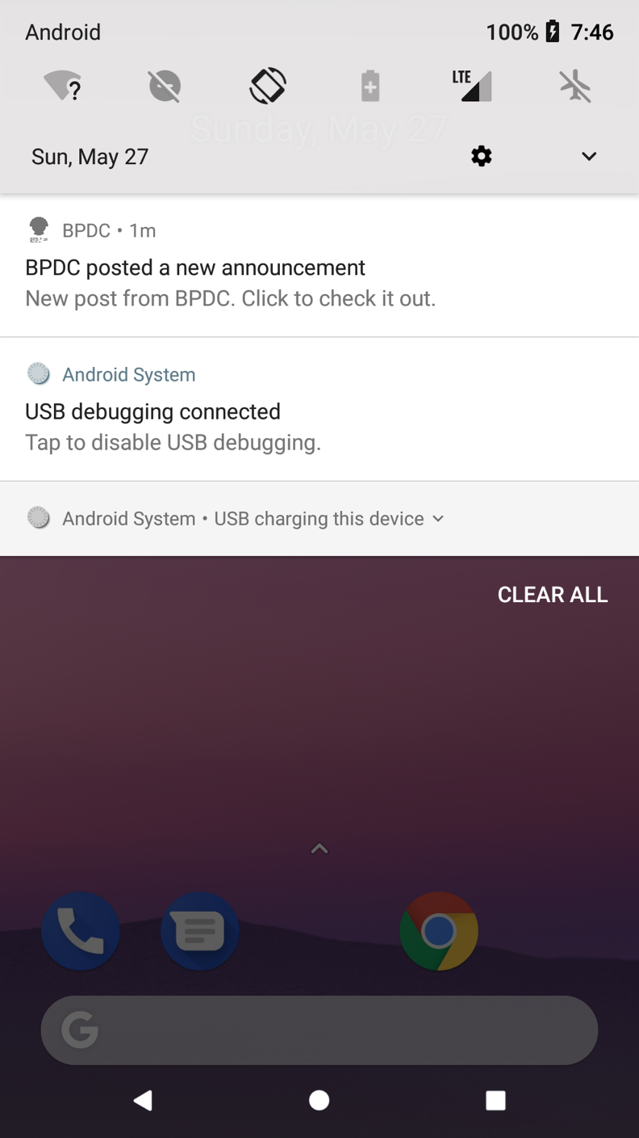

**Screenshot 1 NOTIFICATION INTERFACE**

In screenshot-1, the Notification Interface is shown. How the notification comes whenever a new upload has been made.

**8.2 SCREENSHOT FOR SHOW UPLOADS**

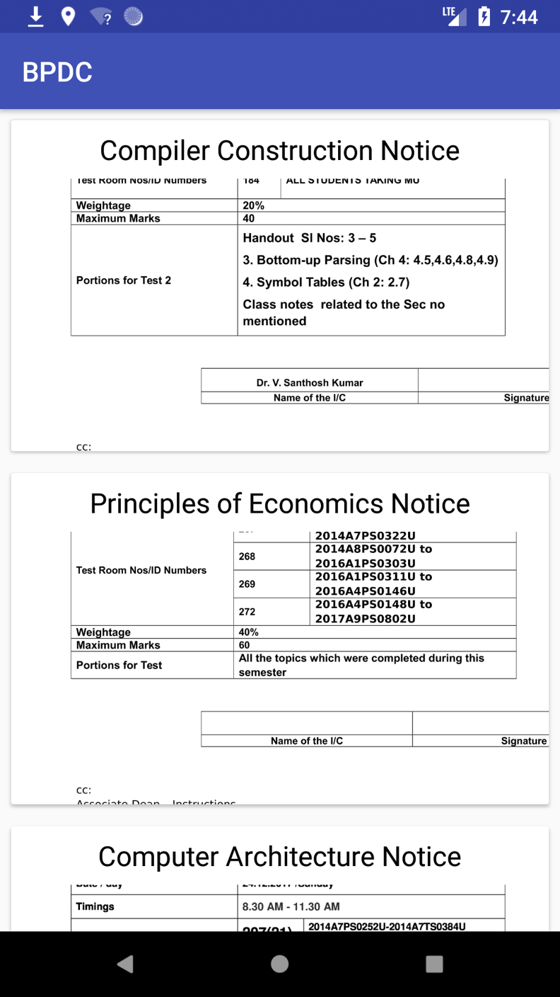

**SCREENSHOT 2 SHOW UPLOAD DETAILS**

In screenshot-2, the uploads are shown for the students to access it.

**8.3 SCREENSHOT FOR SERVER SIDE**

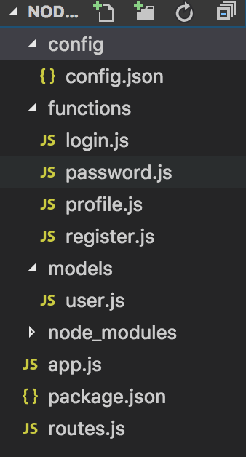

**SCREENSHOT 3 SERVER SIDE STRUCTURE**

In screenshot-3, the Server side structure is shown. It includes all the files which are needed to store the data and all the functions.

**8.4 SCREENSHOT FOR DATA SAVED IN DATABASE**

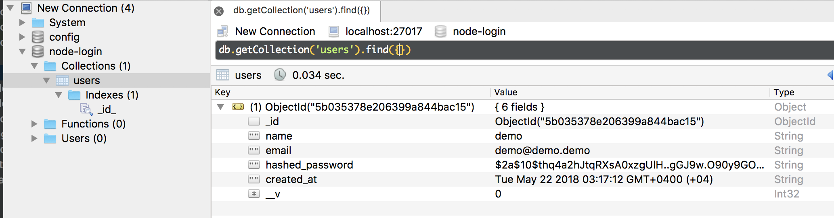

**SCREENSHOT 4 SERVER SIDE STRUCTURE**

In screenshot-4, the data which is being saved in the mongodb database is shown.

**8.5 SCREENSHOT FOR NOTICES SAVED IN THE DATABASE**

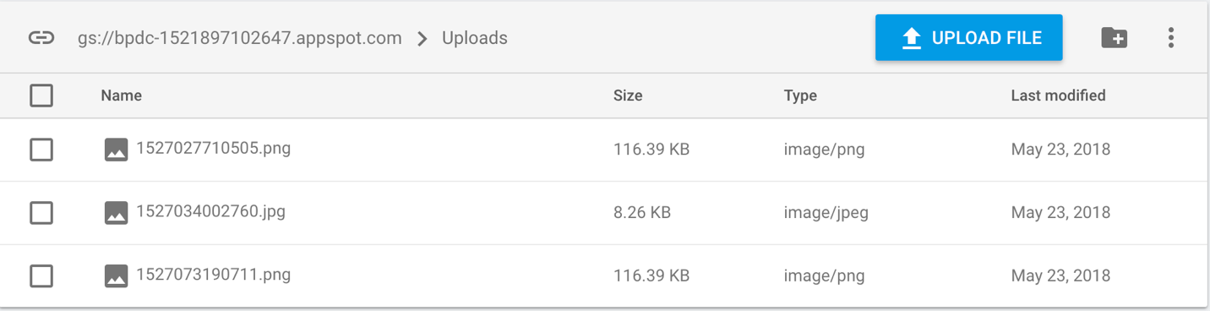

**SCREENSHOT 5 NOTICES UPLOADS**

In screenshot-5, the notices which have been uploaded are shown.

**8.6 SCREENSHOT FOR NOTICES SAVED IN THE DATABASE WITH THE KEY**

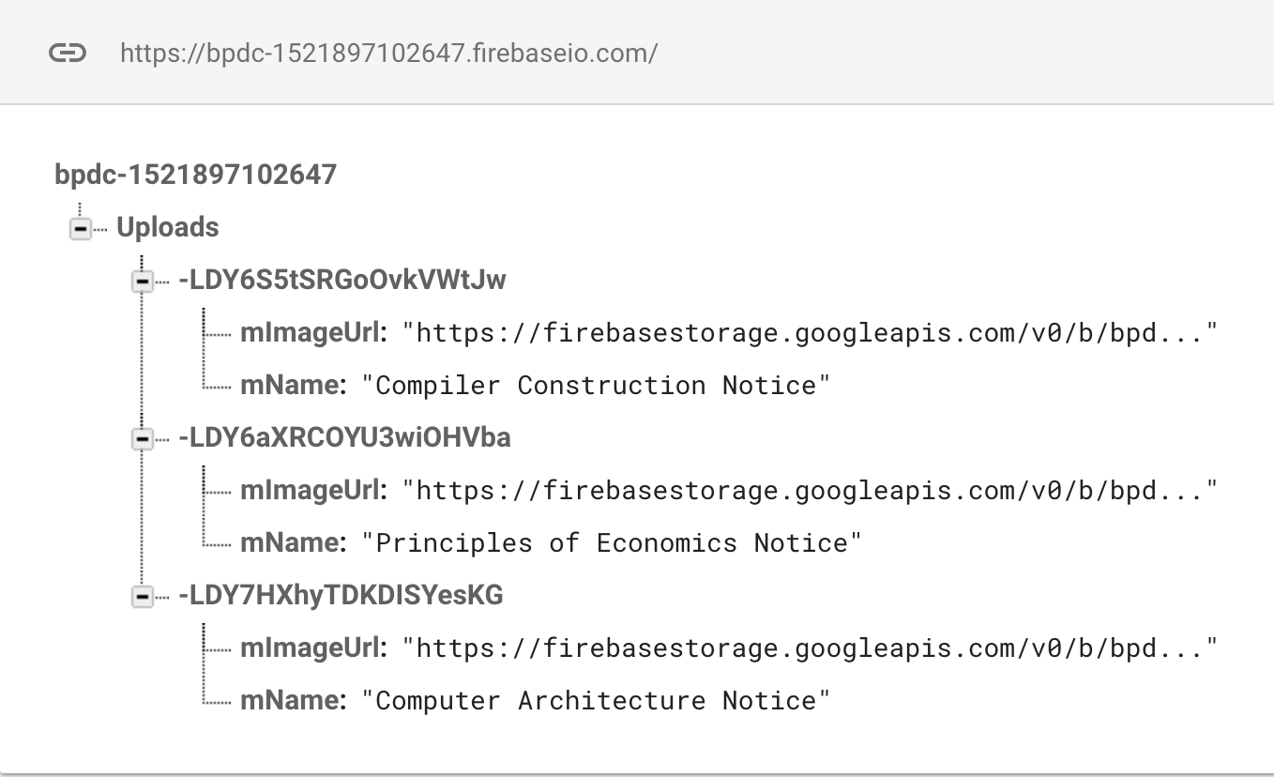

**SCREENSHOT 6 NOTICES UPLOADS WITH KEY**

In screenshot-6, the notices which have been uploaded are shown with their key and the name.

**CHAPTER 8: LIMITATION AND FUTURE SCOPE**

**8.1 LIMITATIONS**

All the thing in this world has some or the other limitations. There doesn’t exist anything in this world, which does not have any kind of limitations. And it is also the case with BPDC. It also has its limitations. Let’s discuss some of the limitations of the application.

In BPDC, the option for recovering password is not working. Here the user cannot make recover the password if forgot. If any user wants to recover the password one new class has to be written which is not there.

There is no list of the students who just gave the attendance. There is no record of the students who marked their attendance in an organized manner making it convenient for everyone.

The UI could be better.

There could be a Chatbot between the teacher and the student for better understanding between them.

**8.2 FUTURE ENHANCEMENTS**

The application can be enhanced in the future in many ways to provide many more functionalities, which is not yet included. As you all know the application is so wide in an area there are so many things, which can come under it. It is not possible to give all the functionality as per the given time and limitations of resources. So here it is discussed with some of the enhancements, which can be made to the application BPDC.

It can be enhanced by detecting more correct location for better results. Beacons could be provided to get even more accurate location. Rooms are close by and we need better technology to make the location as accurate as possible.

Better account management could be done. For example, there could be profile photo feature so that the app looks more interactable.

**Chapter 9: CONCLUSION AND DISCUSSION**

**9.1 CONCLUSION**

The Application made is help the students and the teacher focus on the stuff which is important and let the app take care of things which is less important. With this, students can mark their attendance with just a tap and teachers can upload the notices with ease. This application will make a uniform platform for everyone so that everyone can just concentrate on studying and teaching.

This app will also make the users happy because they need not worry about the attendance not being marked properly or to go around searching for the notices for their next exam. The students can easily mark the attendance and view the notices that’ve been uploaded. The teacher can also easily manage their account and they can easily upload the notices and notify the students.

**9.2 SUMMARY OF PROJECT WORK**

Throughout this project, the working with the organization is one of the best thing and it’s a great learning experience. The privilege of going through whole Software Development Life Cycle and Android Development right from the requirement-gathering phase. Moreover, the concepts are theoretically implemented practically.

While acknowledging all the help provided by the seniors and with due respect and sincere gratitude to the teachers who were helpful to shape out things. The project report is submitted for everyone’s kind consideration. Though the utmost attention is paid to incorporate the maximum facts and figures in the report, I take this opportunity to beg your pardon for any unintentional error in the data that has been collected and incorporated in this report.

**Chapter 10: REFERENCES**

**Websites**

* <https://developer.android.com/studio/index.html>
* <https://www.tutorialspoint.com/android/android_studio.htm>
* <https://firebase.google.com/>
* <http://www.tutorialspoint.com/firebase/>
* <http://freevideolectures.com/Course/3465/Android-Studio>
* <https://www.google.co.in/search?q=java+tutorial&oq=java+tutu&aqs=chrome.1.69i57j0l5.8754j0j4&sourceid=chrome&ie=UTF-8>
* <https://thinkster.io/tutorials/mean-stack>

**Code Link**